1.
> n = 100000
> x=runif(n)
> gx=(1-x^2)^(3/2)
> est=mean(gx)
> est
[1] 0.5880542
> 3*pi/16
[1] 0.5890486
>

To estimate 3*pi/16, we generate x from uniform distribution on the interval [0, 1]. The result is 0.5880542 which is very close to 3*pi/16.

2.
> n = 100000
> x=runif(n,-2,2)
> gx=exp(x+x^2)
> est=4*mean(gx)
> est
[1] 93.93155

By generating uniform distribution on the interval [-2, 2], we get our estimate result 93.93155.

3.
> n = 100000
> x=runif(n)
> y=runif(n)
> prop = sum((x)^2+(y)^2<1)/n
> 4*prop
[1] 3.1464

> pi.stor=NULL
> for(i in 1:1000){
+ x=runif(n)
+ y=runif(n)
- pi.stor[i]=4*sum((x)^2+(y)^2<1)/n}

> mean(pi.stor)
[1] 3.141532
> sd(pi.stor)
[1] 0.005059263

> hist(pi.stor, main = "Histogram of pi approximations")

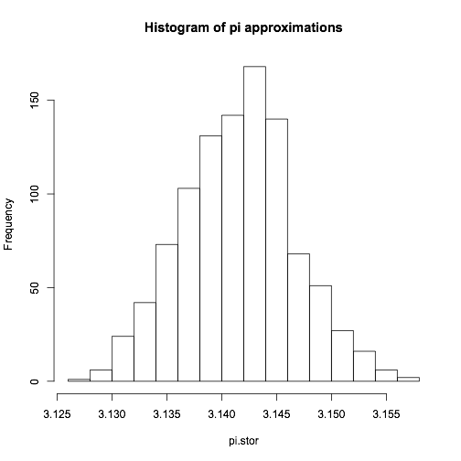

The simulation returned an estimated value of pi and a histogram to pi. By generating 1000 uniform distribution on the interval [0, 1], the estimation of pi with mean 3.141532, and standard deviation 0.005059263 in a bell shape curve.

